Q-1. Open Group Policy Management Console (GPMC) on your Windows Server and create a new GPO named 'PasswordPolicyDemo' that enforces a minimum password length of 8 characters. Link it to your test OU and verify the setting is applied using gpresult.

Step 1: Open Group Policy Management Console (GPMC)
Opened Group Policy Management Console on Windows Server and accessed the lab.com domain.

Step 2: Create the GPO
Created a Group Policy Object named PasswordPolicy under Group Policy Objects.
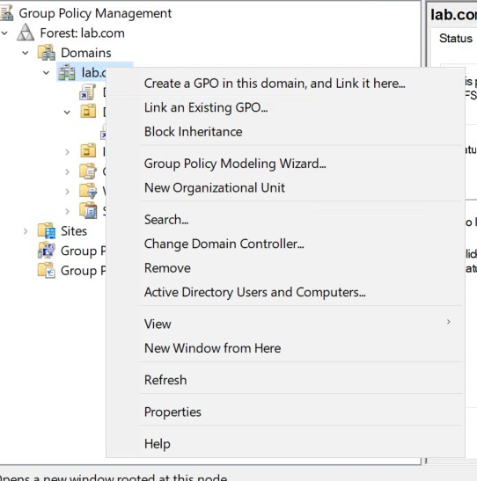

Step 3: Configure Password Policy
Navigated to:
Computer Configuration → Policies → Windows Settings → Security Settings → Account Policies → Password Policy

Configured the Minimum password length setting to 8 characters.
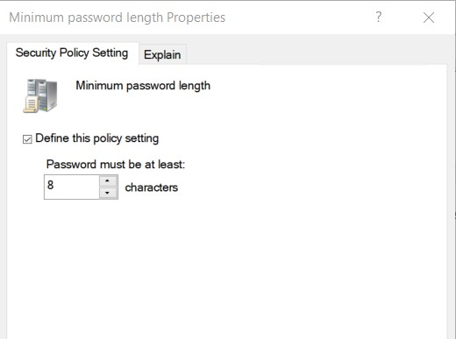

Step 4: Link the GPO
Linked the GPO to the test Organizational Unit (IT OU).

Step 5: Update Group Policy
On the Windows 10 client, executed:
gpupdate /force

Step 6: Verify the Applied GPO
Generated the Group Policy results report and checked the Applied GPOs section. The report showed Default Domain Policy and PasswordPolicy.

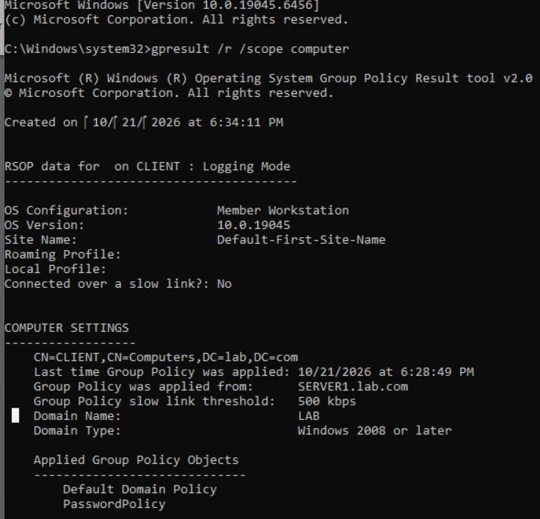

Q-2. Configure a GPO to restrict access to the Control Panel for all users in a specific OU, similar to how public computers in a cybercafe or college lab prevent users from changing system settings.<br><br><em><strong>Hint:</strong> In the GPO, navigate to User Configuration > Administrative Templates > Control Panel and set 'Prohibit access to Control Panel and PC settings' to Enabled.</em>

Step 1: Open Group Policy Management Console
Opened Group Policy Management Console (GPMC) on Windows Server using the gpmc.msc command.

Step 2: Create a New GPO
Created a new Group Policy Object named BlockControlPanel under the Group Policy Objects container.

Step 3: Configure the Policy
Edited the GPO and navigated to:
User Configuration → Policies → Administrative Templates → Control Panel
Opened the setting Prohibit access to Control Panel and PC settings, selected Enabled, and clicked Apply and OK.
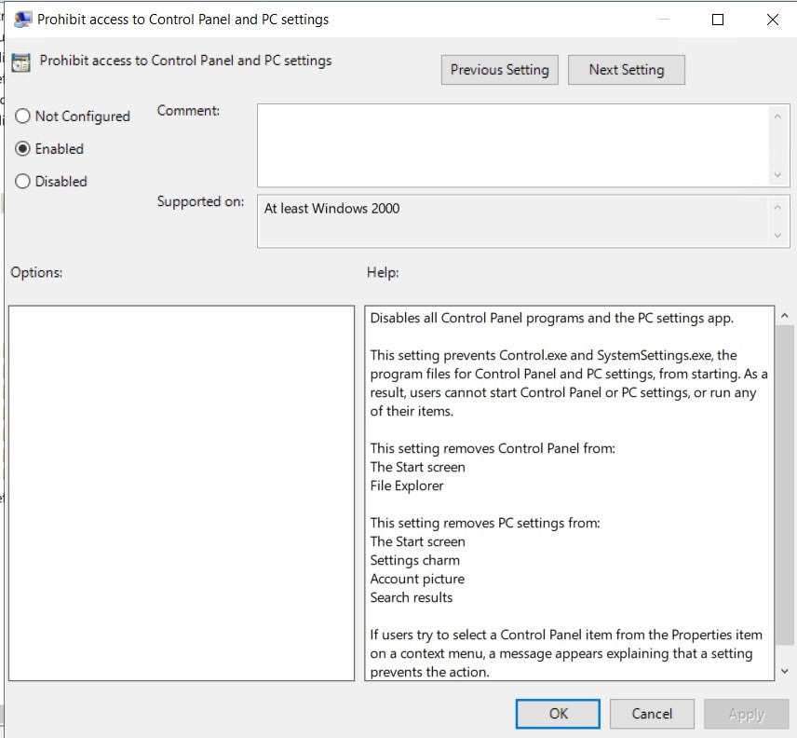

Step 4: Link the GPO to the IT OU
Linked BlockControlPanel to the IT Organizational Unit under the lab.com domain using Link an Existing GPO.

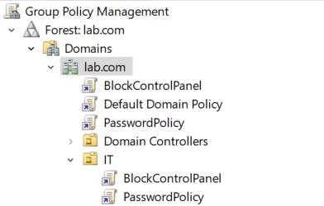

Step 5: Update Group Policy on the Client
Logged in to the Windows 10 client using a domain user account located in the IT OU and executed: gpupdate /force

Step 6: Verify the Applied Policy
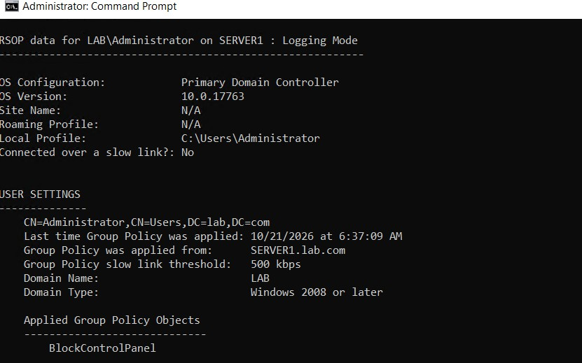

Control Panel Block
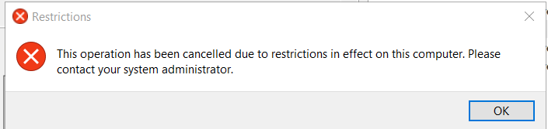

Q-3. Edit your 'PasswordPolicy' GPO to enable account lockout after 3 invalid login attempts and set the lockout duration to 10 minutes. Run gpupdate /force on a client PC and test the lockout by entering the wrong password.
Step 1: Open Group Policy Management Console
Opened Group Policy Management Console (GPMC) on Windows Server using the gpmc.msc command.
Navigated to Forest: lab.com → Domains → lab.com → Group Policy Objects. Step 2: Edit the PasswordPolicy GPO
Right-clicked the existing PasswordPolicy GPO and selected Edit. Navigated to:
Computer Configuration → Policies → Windows Settings → Security Settings → Account Policies → Account Lockout Policy
Step 3: Configure Account Lockout Settings
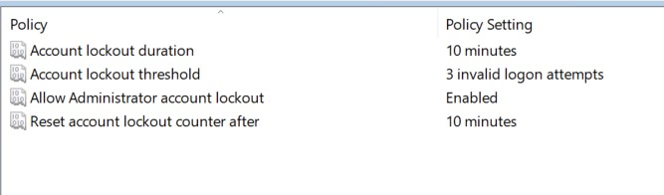
Step 4: Update Group Policy on the Client
On the Windows 10 domain-joined client, opened Command Prompt as Administrator and executed:
gpupdate /force

Step 5: Verify the Applied Policy

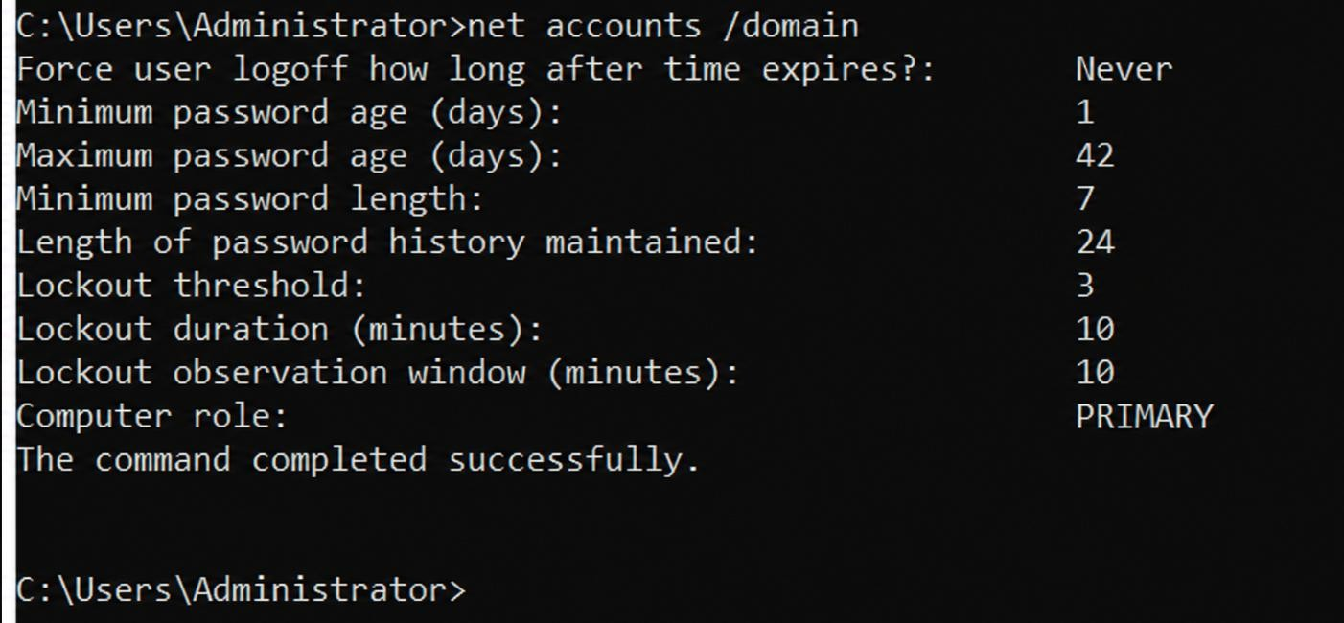

The PasswordPolicy GPO was configured with an account lockout threshold of 3 invalid login attempts and an account lockout duration of 10 minutes. The effective settings and client-side lockout behavior were checked.

Q-4. Document all GPO settings you applied in this session (password policy, desktop restriction, lockout policy) in a table format, and for each setting, describe its expected impact on users in 1-2 sentences.

No. | GPO / Policy | Setting | Configured value | Expected impact on users
1 | PasswordPolicy | Minimum password length | Intended: 8 characters; observed effective value: 7 | Users would need to create passwords meeting the effective minimum length. The latest net accounts /domain output showed 7, so the intended 8-character setting still needs verification.
2 | BlockControlPanel | Prohibit access to Control Panel and PC settings | Enabled | Users whose accounts are in the targeted IT OU should be prevented from opening Control Panel and Windows Settings. This helps stop users from changing system  configurations on shared computers.

3 | PasswordPolicy | Account lockout threshold | 3 invalid attempts | A domain account should become locked after three unsuccessful sign-in attempts, helping protect against repeated password guessing.
4 | PasswordPolicy | Account lockout duration | 10 minutes | A locked account should automatically become available after 10 minutes, provided the effective domain policy specifies this duration.
5 | PasswordPolicy | Reset account lockout counter after | 10 minutes | If no further failed sign-in attempts occur during the observation period, the failed-attempt counter resets. This reduces the chance of occasional mistakes accumulating indefinitely.

